|  |  |  |  |
| --- | --- | --- | --- |
| **SUPPLIER** | FABTECH | | |
| **PROJECT** | : EMPLOYEE MANAGEMENT SYSTEM | **P.O NO.** | : |
| **LOCATION** | : MALAYSIAN REFINING COMPANY SDN BHD | **PROJECT DOC. NO.** | : IUSB/FABTECH/UTM/19/01 |
| **EQUIPMENT** | : ENERGY MONITORING SYSTEM FOR OFF-GRID SOLAR POWER SYSTEM | **SUPPLIER DOC. NO.** | : FABTECH-UAT-001 |

USER ACCEPTANCE TEST

**TEST CASE (WEB BASED)**

|  |
| --- |
|  |

|  |  |
| --- | --- |
| **Test Case ID:** Test_FR-W1 | **Test Designed by:** |
| **Test Priority (Low/Medium/High):** High |  |
| **Module Name:** Web-based application |  |
| **Test Title:** Verify sign in with valid username and password | **Test Designed date:** 24/11/2019 |
| **Description:** Test the web sign in page | **Test Executed by:** |
|  | **Test Execution date:** |
|  |  |
| **Pre-conditions:** User is registered and logged in | |
| **Dependencies:** | |

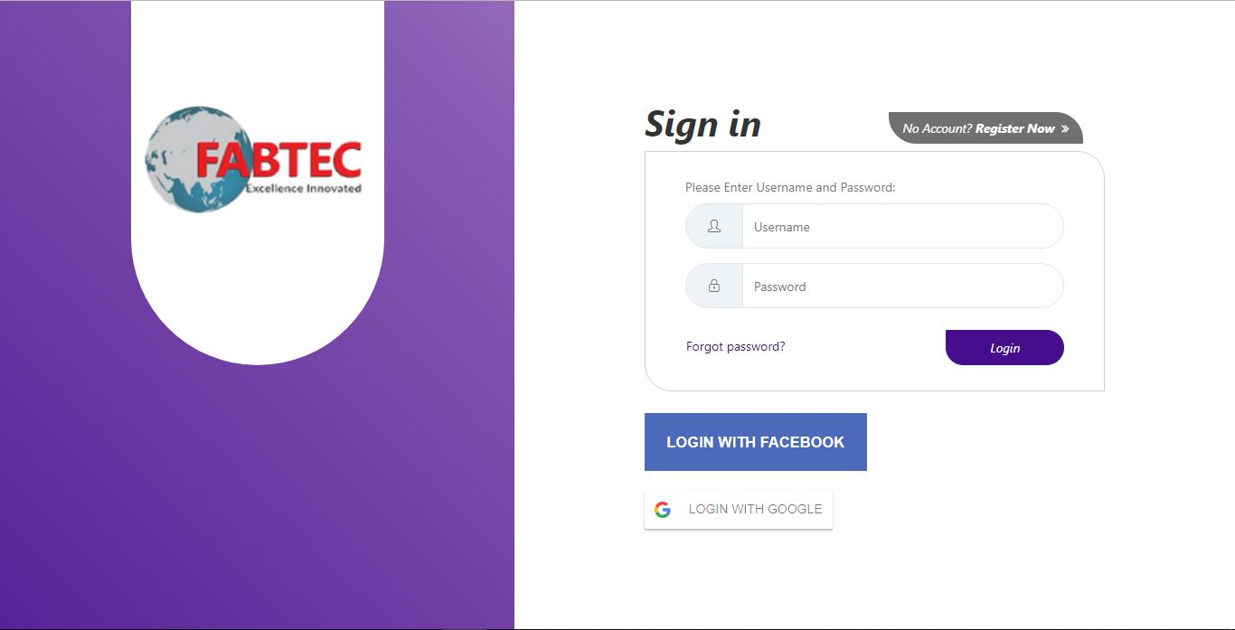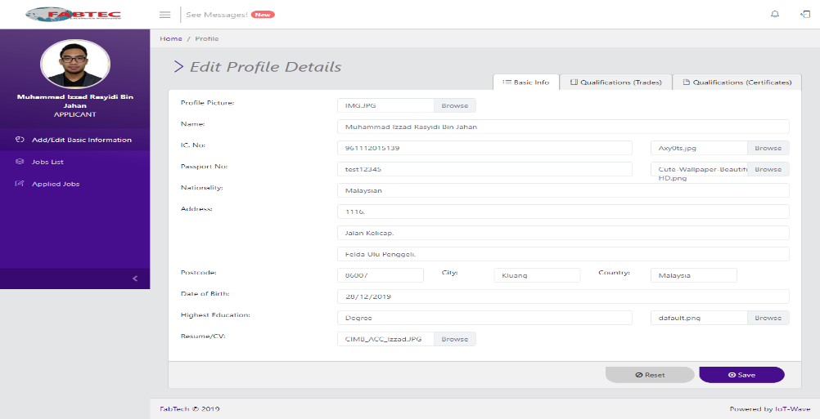

|  |  |  |  |  |  |  |
| --- | --- | --- | --- | --- | --- | --- |
| **Step** | **Test Steps** | **Test Data** | **Expected Result** | **Actual Result** | **Status (Pass/Fail)** | **Notes** |
| 1 | Launch the login web screen |  |  |  |  |  |
| 2 | Provide a valid respective username | Username = |  |  |  |  |
| 3 | Provide a valid respective password | Password = |  |  |  |  |
| 4 | Click on Login button |  | User should be able to login and enter Dashboard page |  |  |  |

**Post-conditions:**

User is validated and successfully logs in

|  |  |
| --- | --- |
| **Test Case ID:** Test_FR-W3 | **Test Designed by:** |
| **Test Priority (Low/Medium/High):** High |  |
| **Module Name:** Web-based application |  |
| **Test Title:** Edit Profile Details | **Test Designed date:** 24/11/2091 |
| **Description:** Test the web edit profile details page | **Test Executed by:** |
|  | **Test Execution date:** |
|  |  |
| **Pre-conditions:** User is registered and logged in (user is applicant) | |
| **Dependencies:** | |

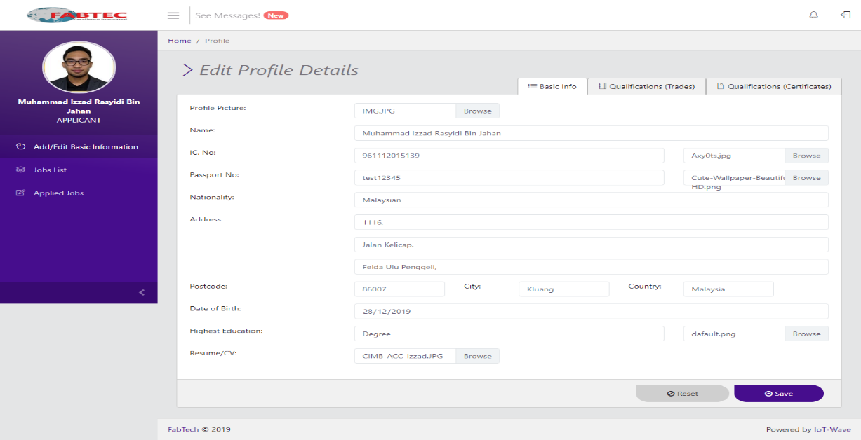

|  |  |  |  |  |  |  |
| --- | --- | --- | --- | --- | --- | --- |
| **Step** | **Test Steps** | **Test Data** | **Expected Result** | **Actual Result** | **Status (Pass/Fail)** | **Notes** |
| 1 | Launch the Edit profile Details screen |  | User should be able to see details of user profile |  |  |  |
| 2 | Click on Browse button for Profile Picture |  | User should be able to add profile picture |  |  |  |
| 3 | Fill in the Name field |  |  |  |  |  |
| 4 | Fill in the Ic No. field and click on Browse button |  | User should be able to add pic of IC |  |  |  |
| 5 | Fill in the Passport No. field and click on Browse button |  | User should be able to add pic of passport |  |  |  |
| 6 | Fill in Nationality field |  |  |  |  |  |
| 7 | Fill in Address field |  |  |  |  |  |
| 8 | Fill in Postcode field |  |  |  |  |  |
| 9 | Fill in City field |  |  |  |  |  |
| 10 | Fill in Country field |  |  |  |  |  |
| 11 | Fill in Date of Birth field |  |  |  |  |  |
| 12 | Fill in the Highest Education field and click on Browse button |  | User should be able to add pic of certificate |  |  |  |
| 13 | Fill in the Resume/CV field and click on Browse button |  | User should be able to add pic of CV or resume |  |  |  |
| 14 | Click on Reset button |  | User should be able to reset all information details |  |  |  |
| 15 | Click on Save button |  | User should be able to save information details |  |  |  |

**Post-conditions:**

Users successfully edit information details

|  |  |
| --- | --- |
| **Test Case ID:** Test_FR-W4 | **Test Designed by:** |
| **Test Priority (Low/Medium/High):** High |  |
| **Module Name:** Web-based application |  |
| **Test Title:** Edit Basic Qualification of User | **Test Designed date:** 24/711/2019 |
| **Description:** Test the web Basic Qualification page | **Test Executed by:** |
|  | **Test Execution date:** |
|  |  |
| **Pre-conditions:** User is registered and logged in (user is applicant) | |
| **Dependencies:** | |

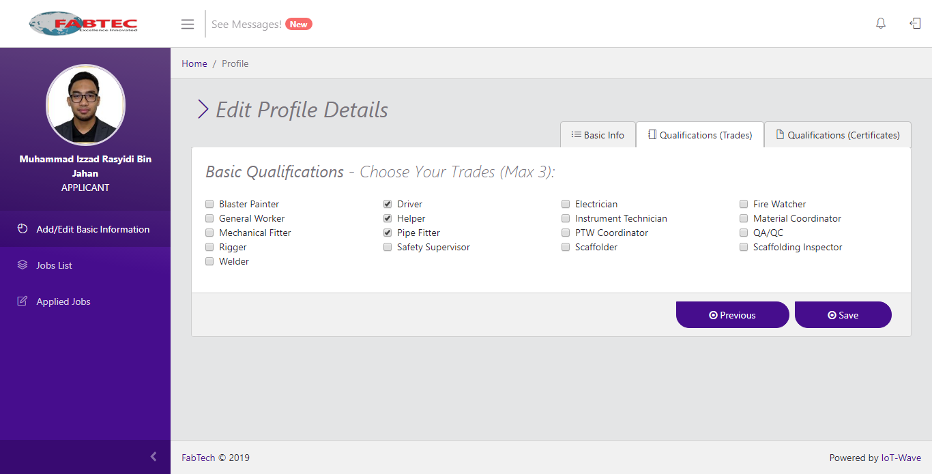

|  |  |  |  |  |  |  |
| --- | --- | --- | --- | --- | --- | --- |
| **Step** | **Test Steps** | **Test Data** | **Expected Result** | **Actual Result** | **Status (Pass/Fail)** | **Notes** |
| 1 | Click on Qualification (Trades) tab |  | User should be redirected to Basic Qualification page |  |  |  |
| 2 | Check on any 3 trades |  | User should be able to check at most 3 trades |  |  |  |
| 3 | Click on Previous button |  | User should be able to return to Basic Info page |  |  |  |
| 4 | Click on Save button |  | User should be able to save the information details |  |  |  |

**Post-conditions:**

|  |  |
| --- | --- |
| **Test Case ID:** Test_FR-W5 | **Test Designed by:** |
| **Test Priority (Low/Medium/High):** High |  |
| **Module Name:** Web-based application |  |
| **Test Title:** Edit Basic Qualification (Certification) page | **Test Designed date:** 24/11/2019 |
| **Description:** Test the web log out Basic Qualification (Certification) page | **Test Executed by:** |
|  | **Test Execution date:** |
|  |  |
| **Pre-conditions:**  User is registered and logged in (user is applicant) | |
| **Dependencies:** | |

Basic Qualification (Trades) is successfully updated

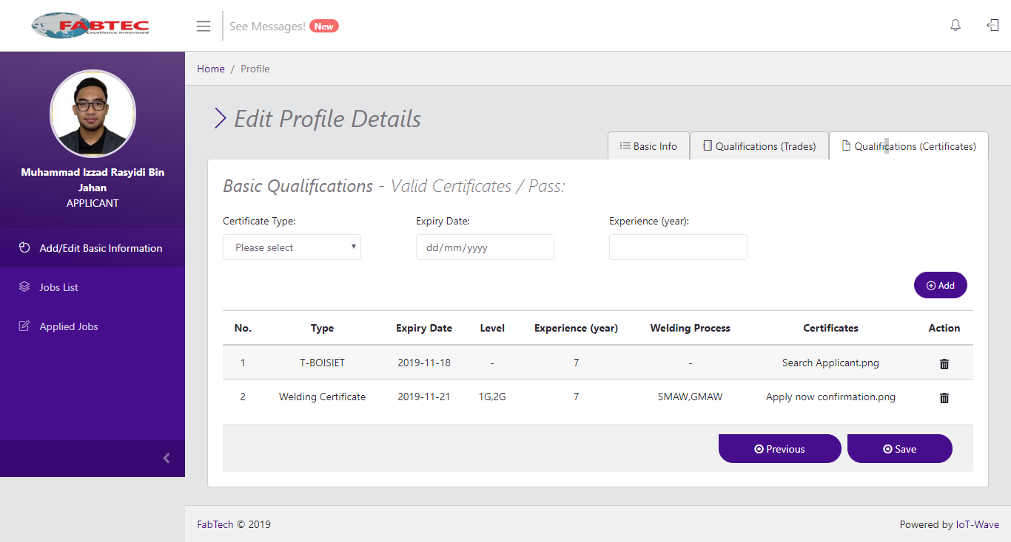

|  |  |  |  |  |  |  |
| --- | --- | --- | --- | --- | --- | --- |
| **Step** | **Test Steps** | **Test Data** | **Expected Result** | **Actual Result** | **Status (Pass/Fail)** | **Notes** |
| 1 | Click on Qualification (Certification) tab |  | User should be redirected to Basic Qualification page |  |  |  |
| 2 | Click on Certificate Type dropdown |  | User able to select the type of certificate they have |  |  |  |
| 3 | Click on Expiry Date dropdown |  | User able to select the expiry date of their certificate |  |  |  |
| 4 | Fill in Experience (year) field |  |  |  |  |  |
| 5 | Click on Add button |  | User should be able to add the details to the table |  |  |  |
| 6 | Click on Trash Icon |  | User should be able to delete details |  |  |  |
| 7 | Click on Previous button |  | User should be able to return to Qualification (Trades) page |  |  |  |
| 8 | Click on Save button |  | User should be able to save the information details |  |  |  |

**Post-conditions:**

Basic Qualification (Certification) is successfully updated

|  |  |
| --- | --- |
| **Test Case ID:** Test_FR-W6 | **Test Designed by:** |
| **Test Priority (Low/Medium/High):** High |  |
| **Module Name:** Web-based application |  |
| **Test Title:** Viewing Available Jobs | **Test Designed date:** 24/11/2019 |
| **Description:** Test to view jobs available | **Test Executed by:** |
|  | **Test Execution date:** |
|  |  |
| **Pre-conditions:**  User is registered and logged in (user is applicant) | |
| **Dependencies:** | |

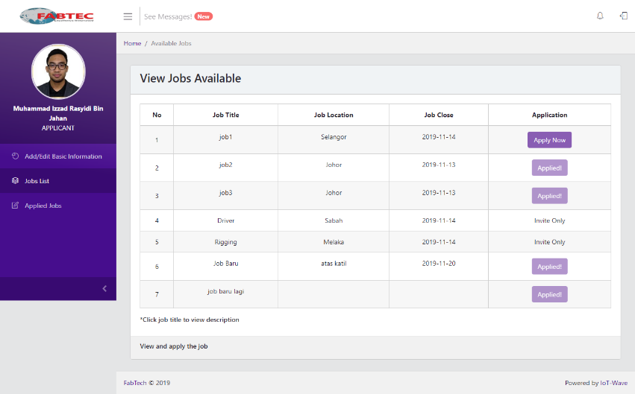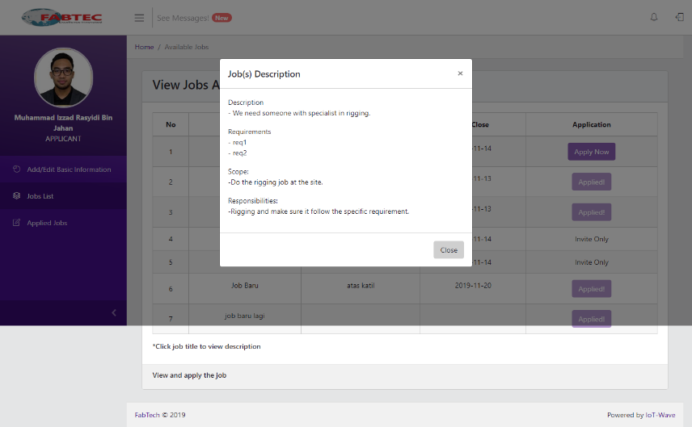

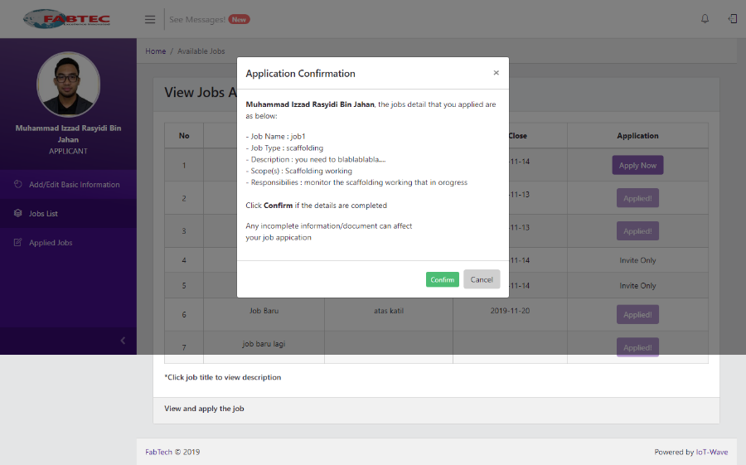

|  |  |  |  |  |  |  |
| --- | --- | --- | --- | --- | --- | --- |
| **Step** | **Test Steps** | **Test Data** | **Expected Result** | **Actual Result** | **Status (Pass/Fail)** | **Notes** |
| 1 | Launch the Jobs List screen |  | User should be able to view a list of jobs available |  |  |  |
| 2 | Click on Job Title listed in Job Title table |  | User able to view the descriptions, requirements, scope and responsibility of the job |  |  |  |
| 3 | Click on Apply Now button |  | User able to view job’s scope and requirement. User should also be able to confirm the job application |  |  |  |

**Post-conditions:**

User successfully view jobs list

|  |  |
| --- | --- |
| **Test Case ID:** Test_FR-W7 | **Test Designed by:** |
| **Test Priority (Low/Medium/High):** High |  |
| **Module Name:** Web-based application |  |
| **Test Title:** Viewing Jobs Applied | **Test Designed date:** 24/11/2019 |
| **Description:** Test to view jobs applied | **Test Executed by:** |
|  | **Test Execution date:** |
|  |  |
| **Pre-conditions:**  User is registered and logged in (user is applicant) | |
| **Dependencies:** | |

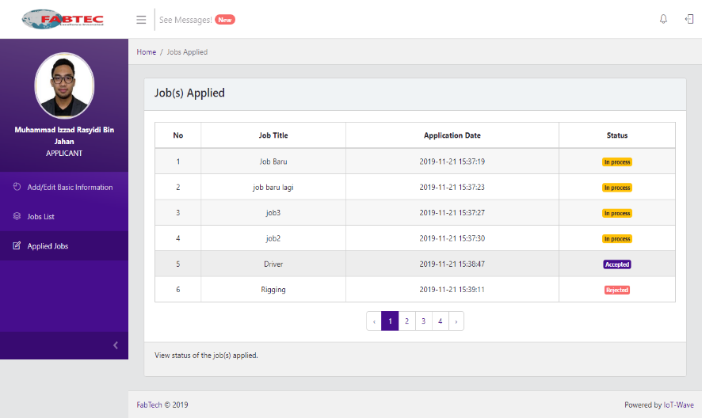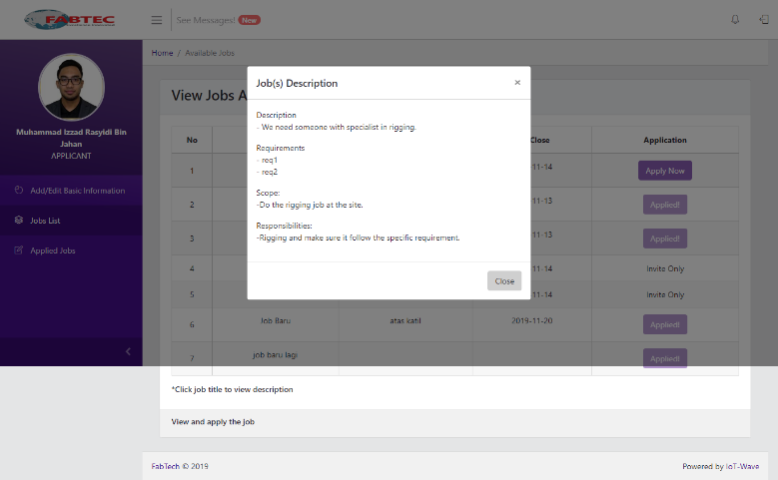

|  |  |  |  |  |  |  |
| --- | --- | --- | --- | --- | --- | --- |
| **Step** | **Test Steps** | **Test Data** | **Expected Result** | **Actual Result** | **Status (Pass/Fail)** | **Notes** |
| 1 | Launch the Applied Jobs screen |  | User should be able to view a list of jobs applied, application date and status of application |  |  |  |
| 2 | Click on Job Title listed in Job Title table |  | User should be able to view the descriptions, requirements, scope and responsibility of the job |  |  |  |
| 3 | Click on the pagination |  | User should be able to view more job application |  |  |  |

**Post-conditions:**

User successfully view jobs applied

|  |  |
| --- | --- |
| **Test Case ID:** Test_FR-W8 | **Test Designed by:** |
| **Test Priority (Low/Medium/High):** High |  |
| **Module Name:** Web-based application |  |
| **Test Title:** Viewing Job Invitation | **Test Designed date:** 24/11/2019 |
| **Description:** Test to view jobs that has been invited | **Test Executed by:** |
|  | **Test Execution date:** |
|  |  |
| **Pre-conditions:**  User is registered and logged in (user is applicant) | |
| **Dependencies:** | |

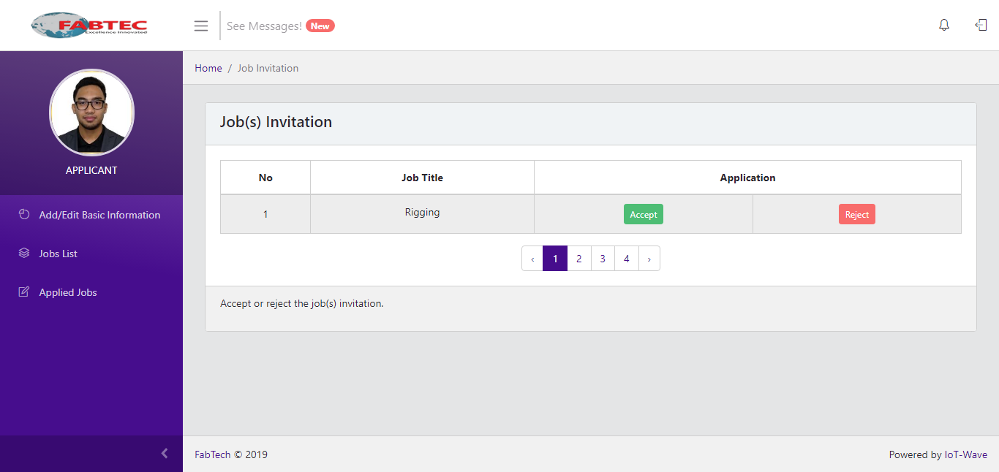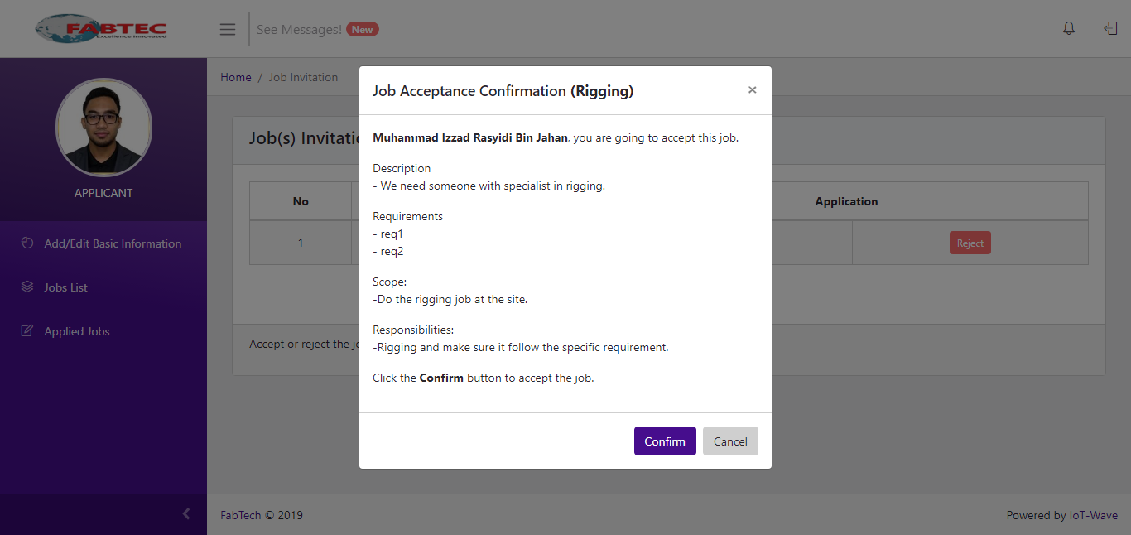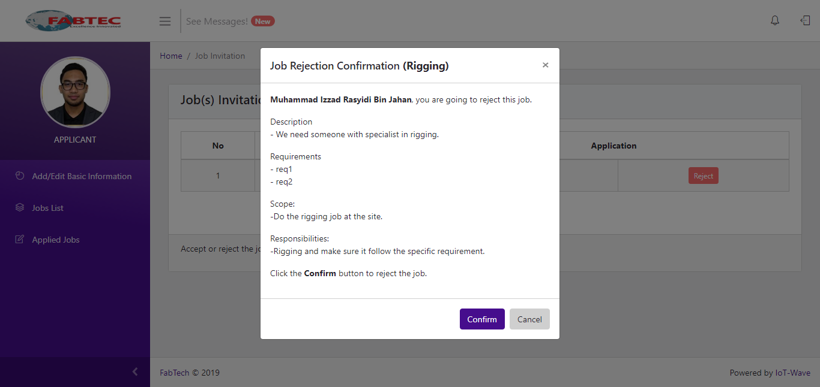

|  |  |  |  |  |  |  |
| --- | --- | --- | --- | --- | --- | --- |
| **Step** | **Test Steps** | **Test Data** | **Expected Result** | **Actual Result** | **Status (Pass/Fail)** | **Notes** |
| 1 | Click on the Bell icon |  | User should be redirected to Jobs Invitation page |  |  |  |
| 2 | Click on Job Title listed in Job Title table |  | User should be able to view the descriptions, requirements, scope and responsibility of the job |  |  |  |
| 3 | Click on Accept button |  | User able to view job’s scope and requirement. User should also be able to confirm the job application |  |  |  |
| 4 | Click on Reject button |  | User able to view job’s scope and requirement. User should also be able to reject the job application |  |  |  |
| 5 | Click on the pagination |  | User should be able to view more job application |  |  |  |

**Post-conditions:**

User successfully view invited job offers

|  |  |
| --- | --- |
| **Test Case ID:** Test_FR-W8 | **Test Designed by:** |
| **Test Priority (Low/Medium/High):** High |  |
| **Module Name:** Web-based application |  |
| **Test Title:** Viewing Job Invitation | **Test Designed date:** 24/11/2019 |
| **Description:** Test to view jobs that has been invited | **Test Executed by:** |
|  | **Test Execution date:** |
|  |  |
| **Pre-conditions:**  User is registered and logged in (user is applicant) | |
| **Dependencies:** | |

|  |  |
| --- | --- |
| **Test Case ID:** Test_FR-W9 | **Test Designed by:** |
| **Test Priority (Low/Medium/High):** High |  |
| **Module Name:** Web-based application |  |
| **Test Title:** Viewing Messages | **Test Designed date:** 24/11/2019 |
| **Description:** Test to view messages from the company | **Test Executed by:** |
|  | **Test Execution date:** |
|  |  |
| **Pre-conditions:**  User is registered and logged in (user is applicant) | |
| **Dependencies:** | |

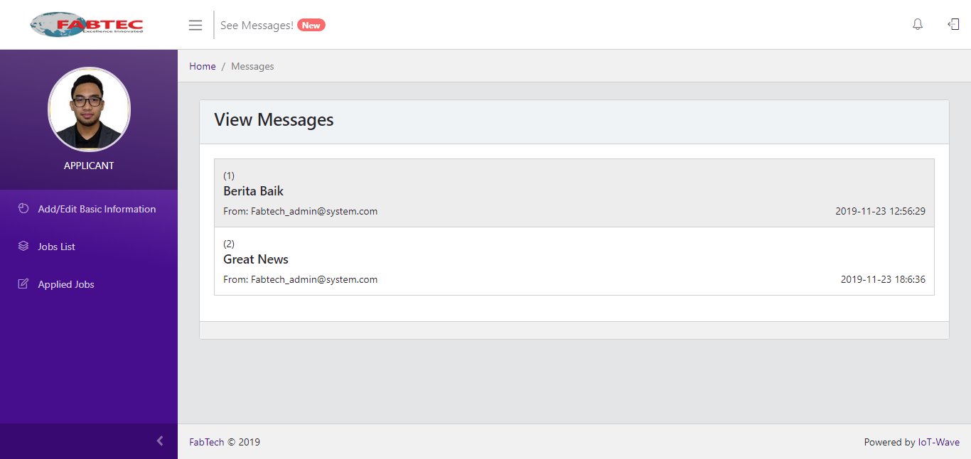

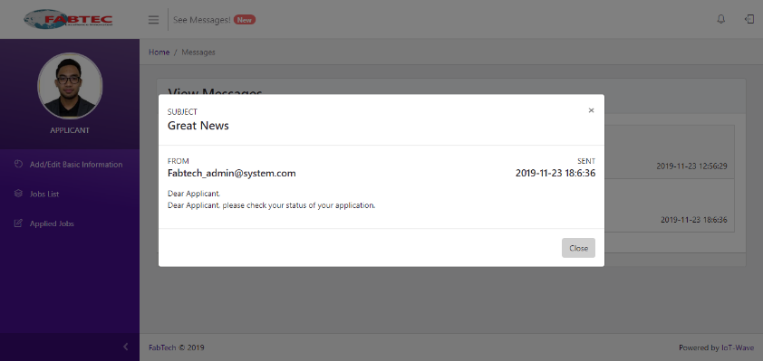

|  |  |  |  |  |  |  |
| --- | --- | --- | --- | --- | --- | --- |
| **Step** | **Test Steps** | **Test Data** | **Expected Result** | **Actual Result** | **Status (Pass/Fail)** | **Notes** |
| 1 | Click on the Message button |  | User should be redirected to the Messages page |  |  |  |
| 2 | Click on a message |  | User should be able to view the notification given by the company |  |  |  |

**Post-conditions:**

User successfully view message

|  |  |
| --- | --- |
| **Test Case ID:** Test_FR-W10 | **Test Designed by:** |
| **Test Priority (Low/Medium/High):** High |  |
| **Module Name:** Web-based application |  |
| **Test Title:** Verify Logout | **Test Designed date:** 24/11/2019 |
| **Description:** Test the web log out | **Test Executed by:** |
|  | **Test Execution date:** |
|  |  |
| **Pre-conditions:**  User is registered and logged in (user is applicant) | |
| **Dependencies:** | |

|  |  |  |  |  |  |  |
| --- | --- | --- | --- | --- | --- | --- |
| **Step** | **Test Steps** | **Test Data** | **Expected Result** | **Actual Result** | **Status (Pass/Fail)** | **Notes** |
| 1 | On any page, click on the Logout button |  | User should be able to logout |  |  |  |

**Post-conditions:**

User successfully logout from web